

From: Robert Lieb

To: Christoph Gorder

Charity Water

CC: Paul Severino, Ralph Cassara, Craig Brekne

IPS

Date: Oct 2, 2018

Subject: Afridev2 Integration Test Plan

Table of Contents

1 Introduction 2

2 White Box Testing 2

2.1 Verifying Water Sensing Capability of a System 3

2.2 Verifying GPS Capability of a System 3

2.3 Verifying Modem Capability of a System 4

2.4 Tuning Water Sensing Accuracy of a System 4

2.5 Verifying Water Sensing Accuracy of a System 5

2.6 Verifying Correct operation across the Operational Temperature Range of a System 8

3 Black Box Testing 9

3.1 Verifying the messages sent when the unit first powers up 9

3.1.1 Final Assembly Message 9

3.1.2 Monthly Check-in Message 10

3.2 Verifying the activation of the unit 10

3.3 Verifying the GPS fix of the unit 10

3.4 Changing the Water Reporting Interval 11

3.4.1 Update Transmission Rate 12

3.5 Testing Daily Water Reporting 12

3.5.1 Daily Water Log 12

3.6 Testing Red Flag detection 14

3.6.1 Modify product code to pre-load the Red Flag Threshold Table 14

3.6.2 Test the triggering of a Red Flag alert 14

3.6.3 Test the removal of a Red Flag alert 15

3.6.4 Test the manual clearing of the Red Flag alert with Reset Data Message 15

3.6.5 Test the manual clearing of the Red Flag alert with Reset Red Flag Message 15

3.7 Testing Clock Updates 16

3.7.1 Verify Clock Update Message 16

3.7.2 Verify Storage Clock Alignment Message 17

3.8 Testing GPS Requests 17

3.8.1 GPS Set Measurement Criteria 17

3.8.3 GPS Request New Measurement 18

3.8.4 GPS Request Existing GPS data 18

3.9 Testing System Reset Command 18

3.9.1 The Afridev2 unit has a few commands that are used to reset the unit’s processor and restart the system. 18

3.9.2 Reset Device 18

3.10 In-Field Firmware Update 18

3.10.1 Building the Application Image 18

3.10.2 Obtain the Firmware Upgrade Message file. 19

3.10.3 Copy and Paste Contents of Firmware Upgrade Message file to BodyTrace server 19

# Introduction

The current phase of the Afridev2 project is to integrate the latest Water Detection algorithm developed last year with the latest BodyTrace API driver and SIMCOM SIM900 Modem software. Up to now, the Water Detection was tested in isolation from the rest of the system code. This plan describes how all of the software is tested together on the Production revision of the Afridev2 board and housing.

# White Box Testing

White Box testing refers to tests that involve some exposure to what is happening inside the product firmware.

The Manufacturing Test version of the Afridev code was written to both support the testing of the units being assembled, and to support integration testing of the product firmware release. The unit is connected with a harness cable that allows the unit’s flash to be programmed as well as to view the Firmware’s debug trace. The firmware has all the features of the production software with the Modem functionality disabled. During the factory test, the Manufacturing procedure will perform a GPS measurement and a Water measurement. The results are stored in Flash and hown on the debug trace, both at startup time and when the tests are run.

Figure 1 shows the results of the Manufacturing test at the start of the system. When the test has passed, the manufacturing process will download this data to a file for each unit so we know the baseline capabilities of the system

|  |
| --- |
| ***Afridev2 V2 Manufacturing Test  @r=IntegTest v=01.01.00 d=09/17/2018  @21:13:11 [N40 49.3163,W073 12.4773],q=1,s=06,h=1.5 ,v=y,e=00398  T0002 t=22.9C 0(?)a73c 1(?)9452 2(?)a343 3(?)98b9 4(?)ad8e 5(?)a41f L0F000 P000  T2c86 t=22.1C 0(W)0954 1(W)0745 2(W)0834 3(W)0750 4(W)0857 5(W)0477 L6F900 P100  T0178 t=22.6C 0(A)0000 1(A)0000 2(A)0000 3(A)0000 4(A)0000 5(w)0596 L0F000 P000  ***Manufacturing Test Pass***  T0002 t=24.6C 0(?)a011 1(?)8ae9 2(?)9ce4 3(?)903e 4(?)a6f0 5(?)9bab L0F000 P000 |

Figure 1 Results of a successful Manufacturing Test

The figure shows the version of the firmware, the GPS fix made during the test, the baseline capacitance measurements for air, and pad data for Water and Air.

## Verifying Water Sensing Capability of a System

Debug messages from the Manufacturing Test version of the code were adapted to aid in the determination of a system’s ability to sense water.

Baseline Capacitance

At the startup of the firmware, a baseline capacitance measurement is taken. These values are typically greater than 36864 (0x9000) and less than 41216 (0xA100). These values are the start of determining the “Air Target” capacitance level.

Air Deviation

Four times every 2 seconds, the current capacitance level over each pad is measured. The Air Target capacitance level minus the mean of these four measurements is called the Air Deviation.

The Water Sensing algorithm requires an Air Deviation of 450 counts or more to detect Water. Smaller numbers will yield inconclusive determinations when the water is turbulent.

A viable system will have Baseline Capacitance values close to the target range and all six pads should register an Air Deviation between 700 and 1100 counts.

The Manufacturing Test will display the Baseline Capacitance at startup and Air Deviation values until all six pads are covered with water and then all covered with Air. The Air Deviation values are stored in Flash for Water and Air, and these values are downloaded and stored during the assembly of the unit.

## Verifying GPS Capability of a System

Debug messages from the Manufacturing Test version were added to evaluate the GPS capabilities of the board. When the debug trace reports ***GPS Test Begin***, the system should be taken to a place usually outside where a GPS fix can be obtained.

The debug trace will show the status of the GPS fix data every 4 seconds. Figure 2 shows how each of the fields are interpreted:

|  |  |
| --- | --- |
| GPS TIME | @xx:xx:xx |
| LATITUDE | Nxx xx.xxx |
| LONGITUDE | Wxxx xxx.xxx |
| FIX QUALITY | q=x |
| SATELLITE COUNT | s=xx |
| HDOP SCORE | h-xx.x meters |
| FIX IS VALID | v=x |
| TIME TO FIX | t=xxxxx |

Figure 2 How to interpret the GPS data on the debug trace

The fields are blank in the beginning and they are filled in as the information is detected by the GPS receiver. When the GPS receiver sees 4 or more Satellites, with an HDOP Score of 3 meters or less, and the Fix Quality is 1, then the measurement is accepted and recorded in Flash for the Manufacturing Test.

If the GPS system is not able to see the reading in 15 minutes, then the GPS measurement Times Out. An Afridev2 unit is not viable for GPS measurement unless it demonstrates in the factory at least 1 good GPS measurement.

Upon a passing test, The GPS fix data values are stored in Flash, and these values are downloaded and stored during the assembly of the unit.

## Verifying Modem Capability of a System

For manufacturing purposes, we need to know that the Modem is functioning and has the capability of connecting to the Body Trace server. When a unit has passed both the Water Sensing and the GPS Fix tests, then the unit will have the Production Software loaded on the unit. When the unit powers up for the first time it will attempt to send an Final Assembly message (Opcode = 0x00) to the server.

The “CQT GSM Message Debugger” or BodyTrace web site ( e.g. <http://prov.bodytrace.com/www.cqt.io/raw.html?imei=861508039423348>) supported by Body Trace is referenced to see the successful transmission of the FA message.

Figure 3 shows how the Body Trace server shows the reception of an FA message. If the modem is not working, then no message will appear here for the Modem’s IMEI number

Figure 3 Results of a successful Manufacturing Test

If the message is received, then the Modem has demonstrated its capability to work.

Body Trace reports that the signal strength of the Modem Connection can be requested of the server from the IOT Platform side. This would be good information to collect on the FA message to help with any connection problems at the installation site.

## Tuning Water Sensing Accuracy of a System

The AfriDev system uses a block of 6 capacitive sensor pads to measure the height of water in a water catch area within a well head. “waterDetect” software within the AfriDev unit uses these sensors to detect the presence of air or water covering each of the pads. When water is covering the pad, the measured capacitance goes down, and conversely when air is covering the pad the value goes up.

As mentioned earlier, changing the composition of the housing material or changing the board materials could change the characteristics of the pad sensor. Given the original design of the Afridev2 unit, each 100% covered pad accounted for 61ml/second of water flow. With the new housing, and the thinner boards, a number of trials of collecting pour data was needed to calculate the detected flow rate. For the new grey housing, this has been measured to 75ml/second.

This was done by 5 trials of pumping 4 liters of water on the well. Each trial the actual water collected in a measured pail (to 0.1 l accuracy) was compared to the detected water measurement on the debug trace (Manufacturing build). The flow rate of 75ml/second was arrived by scaling the original 61ml/second rate according to the percentage of error in the measurement.

## Verifying Water Sensing Accuracy of a System

The production “waterDetect” software measures the state of the pads four times every two seconds (every 500 mSec) and it trends this data every two seconds. The software determines at each trending calculation how many pads are covered with water and to what extent they are covered. Note that when the water level goes higher than the highest pad, then all the water that flows above this point is not detected.

Figure 4 shows the profile of pouring attempts at the well. While the user is pumping, the water level hovers around the highest pad on the sensor. When the user stops pumping, the water drains out of the measuring chamber. The system needs to accurately measure the fast water as well as the trickle at the end.

Figure 4 Water flow over time

Water measurement accuracy is calculated by collecting several 4 to 5 liter samples in the manner of Figure 5 and comparing the amount of water poured to the amount reported by the firmware.

|  |  |  |  |
| --- | --- | --- | --- |
| Trial | Measured Flow | Actual Flow | Error % |
| 1 | 3800 | 4541 | 16.32% |
| 2 | 4500 | 4634 | 2.89% |
| 3 | 4600 | 4587 | -0.28% |
| 4 | 4500 | 4471 | -0.65% |
| 5 | 4400 | 4702 | 6.42% |
| Overall | 21800 | 22935 | 4.95% |

Figure 5 Pour data for 2 samples a second, trended every 2 seconds

The Manufacturing Test version of the firmware will output data for every 2 second period when water is seen by the sensor. When the water is no longer seen, the firmware will report the total amount of water pumped in the session.

Figure 6 shows the debug trace data for one session of pumping on the well. Each line represents the Water Sensing data collected over a 2-second period. The data shaded in blue shows the water flow estimate for that period. When the water stops pouring, then the system shows a total pour. In this case 4.498 liters of water was measured.

|  |
| --- |
| T2c84 t=22.1C 0(w)0505 1(?)0390 2(w)0410 3(?)0384 4(w)0389 5(?)0164 L1F000uP000u  T2c86 t=22.1C 0(W)0954 1(W)0745 2(W)0834 3(W)0750 4(W)0857 5(W)0477 L6F900 P100  T2c88 t=22.1C 0(W)0954 1(w)0742 2(w)0830 3(W)0751 4(w)0852 5(W)0491 L6F900 P100  T2c8a t=22.1C 0(w)0952 1(w)0738 2(w)0828 3(W)0758 4(W)0867 5(W)0503 L6F898 P099  T2c8c t=22.1C 0(W)0975 1(W)0757 2(W)0845 3(W)0769 4(W)0877 5(W)0511 L6F900 P100  T2c8e t=22.1C 0(w)0973 1(W)0767 2(w)0839 3(W)0778 4(w)0693 5(a)0117 L5F750 P100  T2c90 t=22.1C 0(w)0942 1(w)0541 2(A)0000 3(A)0000 4(A)0000 5(a)0065 L2F150 P000  T2c92 p=04498ml  T2c92 t=22.1C 0(w)0517 1(A)0000 2(A)0000 3(A)0000 4(A)0000 5(a)0066 L1F000 P000  T2c94 t=22.1C 0(A)0000 1(A)0000 2(A)0000 3(A)0000 4(a)0004 5(a)0057 L0F000 P000 |

Figure 6 Water Sensing data for one session on the well

The debug trace also shows several other important data items:

Green: The system time (T) in hexadecimal is the number of seconds since the system started

Pink: The pad temperature (t=) is the temperature of the air inside the unit, directly under the pads

Grey: The water assessment (?,w,W,a,A) shows the state of the pad, whether it is covered with water (w) or air (a) or inconclusive (?).

Yellow: The air deviation follows the water assessment. It is a decimal number of counts between “air” and the current state. Generally speaking when this is greater than 450, water is present. If this number never was seen over 450, then it is inconclusive.

Red: The detected water level (L) is the number of consecutive pads that have water detected. For production software, detection starts with pad 5 at the bottom and pad0 is at the top, for Manufacturing build the detection starts with pad 0 at the bottom.

Blue: The flow rate (F, p=) is the estimated water flow over all pads for the last 2-second period

Teal: The proportional coverage metric (P) reports the estimated percentage of the highest pad in the water state covered with water. When a water detection is in process, the air deviation number is factored with the maximum air deviation (the water target) to return a percentage figure. The maximum flow rate of 75ml/sec is scaled down by this percentage to calculate the Flow amount for the highest pad.

|  |
| --- |
| T36d2 t=22.3C 0(w)0809 1(w)0622 2(w)0727 3(w)0550 4(w)0667 5(w)0370 L6F877 P085 |

Figure 7 A sample with proportional flow of 85%

Figure 7 shows a sample with proportional flow. In this example, Pad 5 was reported as 85% covered with water and pads 0 to 4 are implied to be covered 100% with water.

Figure 8 shows how flow rate is calculated using the Proportional Coverage metric:

|  |
| --- |
| 2 seconds* (75 + 75 + 75 + 75 + 75 + 75x0.85) = 877.5 ml |

Figure 8 Calculating the flow rate with the Proportional Coverage metric

Note: when water only covers the lowest pad, and the percentile figure is below 75%, then the water data is ignored. This is due to the possibility of water beading near the sensor when almost all the water has poured out. This could be falsely interpreted as a trickle of water for a long time.

Olive: The unknown flag (u) is shown when a pad with inconclusive or air state occurs below a detected water state. The pad sensors are truly independent, and this measurement error occurs at the start of a pour when the water detection begins. When unknown states happen more often than that, it is a sign that the system is malfunctioning. For example, if moisture makes it into the housing, the board can absorb it like a sponge and the pad sensors will get “stuck”, they will lose their sensitivity.

Figure 9 shows a critical failure where the capacitance values rarely go over 450. For this test all the pads were covered with water, and yet air was reported in the lowest pads. All the samples in the debug trace are marked with unknowns because pad 0 is at the bottom and water is “floating” over pads 2 to 5.

|  |
| --- |
| T46a0 t=22.9C 0(A)0372 1(a)0400 2(a)0427 3(W)0543 4(W)0726 5(W)0774 L0F000uP000u  T46a2 t=22.9C 0(A)0352 1(a)0369 2(W)0466 3(w)0472 4(w)0683 5(w)0629 L0F000uP000u  T46a4 t=22.9C 0(A)0350 1(a)0367 2(W)0466 3(w)0473 4(w)0685 5(w)0634 L0F000uP000u  T46a6 t=22.9C 0(A)0351 1(a)0368 2(w)0463 3(w)0473 4(w)0686 5(w)0632 L0F000uP000u |

Figure 9 Flow data when there is no pad behind the pad sensors

Figure 10 shows a single pad being “stuck” with water. This unit has a thin pad behind the board. The board is not pushed firmly against the housing, it is out of the water and yet the capacitance level seen remains at the water level.

|  |
| --- |
| T01d6 t=22.5C 0(a)0020 1(a)0013 2(a)0020 3(a)0009 4(a)0014 5(w)0594 L0F000uP000u  T01d8 t=22.5C 0(a)0022 1(a)0013 2(a)0026 3(a)0017 4(a)0024 5(w)0599 L0F000uP000u  T01da t=22.5C 0(a)0021 1(a)0012 2(a)0020 3(a)0014 4(a)0017 5(w)0596 L0F000uP000u  T01dc t=22.5C 0(a)0014 1(a)0011 2(a)0019 3(a)0019 4(a)0016 5(w)0598 L0F000uP000u  T01de t=22.5C 0(a)0018 1(a)0015 2(a)0027 3(a)0016 4(a)0023 5(w)0601 L0F000uP000u |

Figure 10 Flow data with a thin pad behind the pad sensors

Recently we had a failure where the board was briefly exposed to drops of water near the pads. These boards showed the measurements for pads 1 and 3 being “stuck” off, they were always inconclusive (the air deviation values were never over 450). When we baked the boards overnight and dried them off, the boards were properly measuring data.

## Verifying Correct operation across the Operational Temperature Range of a System

Changes in ambient temperature can change the measurements of the sensors. If the temperature changes enough, it could fool the system to detect water when there is heated air in front of the pads.

To characterize what is going on, experiments were run at IPS labs showed that the effect of temperature changes in front of the pad sensors was a linear change in measured Capacitance. The following chart in Figure 11 shows the linear approximation of the data trended from our experiments.

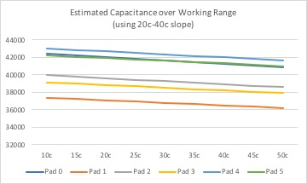

Figure 11 Projected Air capacitance data over working temperature range

The actual collected data was linear between 20C and 40C, and there was a slight slope change both colder and hotter. Using a straight linear approximation tests well.

When the measured Capacitance level changes is 450 or more counts less than the air target, it could trigger a false detection of water. To help eliminate this type of failure, a thermistor was added near the pads that measures the temperature of the air over the pads. When the pad temperature measurement changes up or down 0.1c, the system will adjust the air and water targets up or down according to the slope of the data shown in the chart.

The following table in Figure 12 shows the number of counts the “air target” and “water target” are adjusted for every 0.1c increase in pad temperature.

|  |  |  |  |  |  |
| --- | --- | --- | --- | --- | --- |
| Pad 0 | Pad 1 | Pad 2 | Pad 3 | Pad 4 | Pad 5 |
| -4.01 | -3.02 | -3.45 | -3.12 | -3.45 | -2.99 |

Figure 12 Projected Air capacitance data over working temperature range

The debug trace of the Manufacturing Code will show every time an adjustment is made. Every 2 seconds when the water data is trended, a heat analysis is applied.

When the air or water target values are changed, then the debug trace will show the number of counts. Should the temperature flicker up and down 0.1c, then the adjustment is applied up and down. The following debug data shows these kinds of adjustments.

|  |
| --- |
| T2eee t=23.2C 0(-0004) 1(-0003) 2(-0003) 3(-0003) 4(-0003) 5(-0002)  T2ef0 t=23.2C 0(0004) 1(0003) 2(0003) 3(0003) 4(0003) 5(0002)  T2f04 t=23.3C 0(-0004) 1(-0003) 2(-0003) 3(-0003) 4(-0003) 5(-0002)  T2f26 t=23.2C 0(0004) 1(0003) 2(0003) 3(0003) 4(0003) 5(0002)  T2f78 t=23.3C 0(-0004) 1(-0003) 2(-0003) 3(-0003) 4(-0003) 5(-0002)  T2fa0 t=23.3C 0(0004) 1(0003) 2(0003) 3(0003) 4(0003) 5(0002) |

Figure 13 Debug Trace data shown when Temperature Adjustments are applied to Air and Water Targets

To test the correct effect of this algorithm, a sealed Afridev2 unit with a debug trace could be placed in a heated chamber. While the unit heats up, the adjustments should be seen and no water detection should occur.

If it is not possible to monitor the unit while heating, the unit can be placed in the oven and removed when it stabilizes at 50c. When it comes out of the oven, the unit can be hooked up to monitor the debug trace. Again, the unit should not be detecting water.

# Black Box Testing

Black Box testing refers to tests that are done with little or no knowledge of what is happening inside the product firmware. In the case of Afridev2, these tests are done to validate all the messages and transactions that can occur between the Afridev2 unit and the BodyTrace server.

The BodyTrace server has its own set of code that translates the messages sent to the server to JSON data. This data is sent to the Twisthink server for processing. The tests do not validate this interface.

All tests are based on the “Afridev V2 Remote Sensor Message Definitions” document.

## Verifying the messages sent when the unit first powers up

When the Afridev2 unit starts or re-starts, it will send two messages to the bodytrace server:

### Final Assembly Message

The Sensor sends a Final Assembly message approximately 30 seconds after is starts. The purpose of this message is twofold:

1. It alerts the IoT Platform that the Sensor has restarted and is up and running.

2. It acts as the catalyst to have the IoT Platform send the Sensor a GMT Update

message. In most cases, the Sensor will not receive the GMT Update message until the next time it transmits a message.

To test this message, the battery is connected to a unit with a provisioned modem. The BodyTrace web site is queried for the Modem’s IMEI number and an entry like this should be seen within a few minutes.



Figure 14 Final Acceptance message

### Monthly Check-in Message

The sensor will send a Monthly Check-in message next. The monthly check-in message is used to ensure that the unit will always communicate to the IoT Platform at least once a month. This allows the unit to download any OTA messages from the IoT Platform even if the unit is not yet activated.

To test this message, after the battery is connected and the FA message is sent, this message is sent.



Figure 15 Monthly check-in message

## Verifying the activation of the unit

When the Afridev2 unit starts or re-starts, after it sends the initial messages, the modem is turned off and the unit starts detecting water. When the unit sees 50 liters of water, then it will activate the system.

To test this, a unit built for “plunge mode” needs to be plunged into a bowl of water for 10 seconds at a time and removed. Each iteration should log roughly 4 liters of pouring. Repeating this several times will cause the activation.

The activation should be seen on the Body Trace server as in Figure 16.



*Figure 16 Activation message*

## Verifying the GPS fix of the unit

After the Afridev2 is activated, the need for a GPS measurement is signaled by the Afridev2 firmware. The unit should be brought to a place where a GPS measurement can be obtained for at least 5 minutes (though the measurement typically happens in 1 minute).

The Afridev2 unit will hold on to the measurement until the next Modem connection time. This occurs every 24 hours. At this time, the measurement will be seen on the Body Trace server as in Figure 17



*Figure 17 GPS Location message*

Transferring this data to a spreadsheet, the GPS fix can be obtained:

| Hex data | Decimal | Index in Message | Meaning | Value |
| --- | --- | --- | --- | --- |
| 15 | 21 | 16 | Hours | 21:27 |
| 1b | 27 | 17 | Min |  |
| 02 | 40504169 | 18 | Latitude | 40 50.4169N |
| 6a |  | 19 |  |  |
| 0b |  | 20 |  |  |
| 69 |  | 21 |  |  |
| Fb | -73107269 | 22 | longitude | 73 10.7269W |
| A4 |  | 23 |  |  |
| 78 |  | 24 |  |  |
| Bb |  | 25 |  |  |
| 01 | 1 | 26 | fix quality |  |
| 05 | 5 | 27 | satellites tracked |  |
| 0f | 15 | 28 | hdop value | 1.5m |
| 00 | 0 | 29 | Reserved |  |
| 0090 | 144 | 30 | measurement time (sec) | 144sec |

*Figure 18 GPS Location data in spreadsheet form*

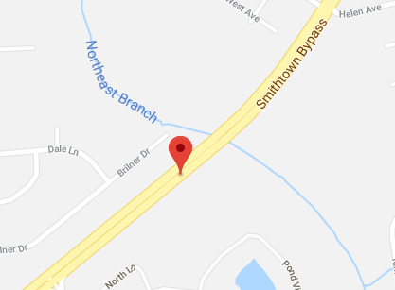Copying the coordinates in Google maps and the location fix can be checked. In this case, the unit was in the back of my car driving towards IPS offices ☺

## Changing the Water Reporting Interval

By default, the unit will broadcast the results of 7 days of water measurements. For testing purposes this interval can be changed with an Over The Air (OTA) message to the unit.

The BodyTrace web site has a form field to the right to send OTA messages to the unit.

### Update Transmission Rate

To test this feature, request daily updates by sending the message 07 a5 5a 01, as shown in Figure 19

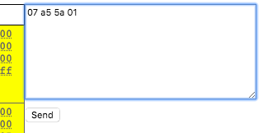

*Figure 19 OTA Message Request Dialog*

This queues up the message to be sent the next time the modem is turned on (every 24h). At the next update, the Afridev unit replies with an OTA Response message (Opcode 3) as shown in Figure 20.



*Figure 20 OTA Response Dialog*

From then on the Water reports should be sent Daily.

## Testing Daily Water Reporting

The Afridev unit will collect water sense data each hour of the day and report it at the end of the day.

### Daily Water Log

To test this, the unit needs to be connected to a well with regular water pumping. The amount of water pumped needs to be tracked to a liter accuracy, At the end of the day the system will report the collected data to the server in a “Daily Water Log” message

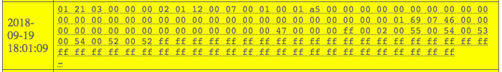

*Figure 21 Daily Water Log Message*

To verify this message, it needs to be carefully parsed into the individual fields in the message. A number of fields are 2 bytes in length, so they need to be reassembled with the right endianness.

Figure 22 shows sample data included in Water Daily Report messages:

|  |  |  |  |  |  |
| --- | --- | --- | --- | --- | --- |
| Field | Report1 | Field | Report1 | Field | Report1 |
| transmit date | 9/20/18 | 0:00 | 0 | 12:00 | 0 |
| transmit time | 18:01:11 | 1:00 | 0 | 13:00 | 0 |
| days msb | 0 | 2:00 | 0 | 14:00 | 0 |
| days lsb | 2 | 3:00 | 0 | 15:00 | 0 |
| sto wk | 0 | 4:00 | 0 | 16:00 | 1827 |
| sto day | 2 | 5:00 | 0 | 17:00 | 0 |
| total liters | 58 | 6:00 | 0 | 18:00 | 0 |
| avg liters | 0 | 7:00 | 0 | 19:00 | 0 |
| red flag | 0 | 8:00 | 0 | 20:00 | 0 |
| unknowns | 1 | 9:00 | 0 | 21:00 | 0 |
| pad 0 | 70 | 10:00 | 0 | 22:00 | 0 |
| pad 1 | 70 | 11:00 | 0 | 23:00 | 0 |
| pad2 | 70 |
| pad3 | 71 |
| pad4 | 70 |
| pad5 | 69 |

*Figure 22 Sample Daily Water Log Message*

For the test to pass, the water data needs to match the water pouring data. Note that the hourly pour figures are in a 32 ml/unit resolution (for RAM savings), so in Figure 22 the value of 1827 corresponds to 1827*32ml or 58464ml which matches the reported total liters of 58.

## Testing Red Flag detection

The Afridev2 unit will trend the daily pumping data over a rolling 28 day (4 week) period. When a day’s total measured liters is less than 25% of the historical average for that day, then a red flag is raised for the unit and a message is sent immediately. The 4-week average for a given day must exceed 200 liters for a red flag to be reported.

To Test this, we need to slightly modify the code to pre-load historical data, or else the test will need to run for over a week.

### Modify product code to pre-load the Red Flag Threshold Table

The following code needs to be added to the storage.c module. Yes this is not very “Black Box”, but we want to cut down the testing time a bit. We are setting the threshold to 204 (greater than 200) liters for each day.

|  |
| --- |
| void **storageMgr_init**(void) {  uint8_t i;  memset(&stData, 0, sizeof(storageData_t));  *// set the threshold to start for testing purposes*  for (i=0; i< TOTAL_DAYS_IN_A_WEEK; i++)  stData.redFlagThreshTable[1] = 204;  *// we don't have 28 days for testing*  stData.redFlagMapDay = RED_FLAG_TOTAL_MAPPING_DAYS;  stData.redFlagDataFullyPopulated = 1; |

*Figure 23 code segment from storage.c*

### Test the triggering of a Red Flag alert

The red flag is triggered when the daily pumping data is less than 25% of the threshold. The test sets the threshold to 204 liters, so 25% of that is 51 liters. So for the first day, don’t pump more than 51 liters, or change the pre-loaded threshold to 4 times what you plan to pump that day.

When the daily water report is sent, the red flag should be indicated:

|  |  |  |  |  |  |
| --- | --- | --- | --- | --- | --- |
| Field | Report1 | Field | Report1 | Field | Report1 |
| transmit date | 9/20/18 | 0:00 | 0 | 12:00 | 0 |
| transmit time | 18:01:11 | 1:00 | 0 | 13:00 | 0 |
| days msb | 0 | 2:00 | 0 | 14:00 | 0 |
| days lsb | 2 | 3:00 | 0 | 15:00 | 0 |
| sto wk | 0 | 4:00 | 0 | 16:00 | 1510 |
| sto day | 2 | 5:00 | 0 | 17:00 | 0 |
| total liters | 48 | 6:00 | 0 | 18:00 | 0 |
| avg liters | 204 | 7:00 | 0 | 19:00 | 0 |
| red flag | 1 | 8:00 | 0 | 20:00 | 0 |
| unknowns | 1 | 9:00 | 0 | 21:00 | 0 |
| pad 0 | 70 | 10:00 | 0 | 22:00 | 0 |
| pad 1 | 70 | 11:00 | 0 | 23:00 | 0 |
| pad2 | 70 | 12:00 | 0 |
| pad3 | 71 | 13:00 | 0 |
| pad4 | 70 | 14:00 | 0 |
| pad5 | 69 | 15:00 | 0 |

*Figure 24 sample report that shows a red flag*

### Test the removal of a Red Flag alert

The red flag indication is removed when the daily pumping data is seen to be more than 75% of the threshold. The test sets the threshold to 204 liters, so 75% of that is 153 liters. So for the second day, pump more than 153 liters, or change the pre-loaded threshold to 1/3 more than what you plan to pump that day.

When the daily water report is sent, the red flag should be cleared:

|  |  |  |  |  |  |
| --- | --- | --- | --- | --- | --- |
| Field | Report1 | Field | Report1 | Field | Report1 |
| transmit date | 9/21/18 | 0:00 | 0 | 12:00 | 0 |
| transmit time | 18:01:11 | 1:00 | 0 | 13:00 | 1002 |
| days msb | 0 | 2:00 | 0 | 14:00 | 998 |
| days lsb | 2 | 3:00 | 0 | 15:00 | 1010 |
| sto wk | 0 | 4:00 | 0 | 16:00 | 990 |
| sto day | 2 | 5:00 | 0 | 17:00 | 1000 |
| total liters | 160 | 6:00 | 0 | 18:00 | 0 |
| avg liters | 204 | 7:00 | 0 | 19:00 | 0 |
| red flag | 0 | 8:00 | 0 | 20:00 | 0 |
| unknowns | 1 | 9:00 | 0 | 21:00 | 0 |
| pad 0 | 350 | 10:00 | 0 | 22:00 | 0 |
| pad 1 | 350 | 11:00 | 0 | 23:00 | 0 |
| pad2 | 350 | 12:00 | 0 |
| pad3 | 350 | 13:00 | 0 |
| pad4 | 350 | 14:00 | 0 |
| pad5 | 349 | 15:00 | 0 |

*Figure 25 sample report that shows a red flag*

### Test the manual clearing of the Red Flag alert with Reset Data Message

The red flag condition can also be cleared manually with an OTA message sent to the unit.

To test this feature, request the reset of stored pour data by sending the message 03 a5 5a, as shown in Figure 26. This will also clear the red flag condition.

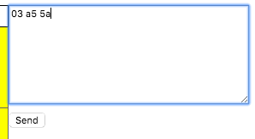

*Figure 26 OTA Message Request Dialog*

This queues up the message to be sent the next time the modem is turned on (every 24h). At the next update, the Afridev unit replies with an OTA Response message (Opcode 3) with the a5 5a pattern in it.

To test this, the red flag condition can be set in the **storageMgr_init**(void) function to save time, and the OTA message can be sent. The next Daily Water Report should have the flag cleared.

### Test the manual clearing of the Red Flag alert with Reset Red Flag Message

The red flag condition can also be cleared manually with an OTA message sent to the unit.

To test this feature, request the reset of the Red Flag alert by sending the message 04 a5 5a, as shown in Figure 27

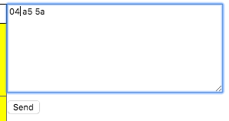

*Figure 27 OTA Message Request Dialog*

This queues up the message to be sent the next time the modem is turned on (every 24h). At the next update, the Afridev unit replies with an OTA Response message (Opcode 4) with the a5 5a pattern in it. The next Daily Water Report should have the flag cleared.

To test this, the red flag condition can be set in the **storageMgr_init**(void) function to save time, and the OTA message can be sent.

## Testing Clock Updates

All measurements are done according to Greenwich Meridian Time (GMT), the time zone that covers London England. There is no RTC hardware on the Afridev2 unit, so a software real time clock is supported.

It is possible for the software internal clock to lose its synchronization to the real time due to the frequency of the processor sleeping, or possible border cases in the operation of the Afridev2 unit, or an unintended restart of the system. To help correct this, an OTA message can be sent to move the RTC ahead a number of seconds, minutes, hours, days.

Additionally, the unit’s time zone may be set to align the data updates to the local “midnight”.

### Verify Clock Update Message

To verify the clock update message, the tester will remove and replace the battery on the Afridev2 unit. This will cause an FA message to be sent with the time 00:00:00. Google gmt time to get the current time as in Figure 28.

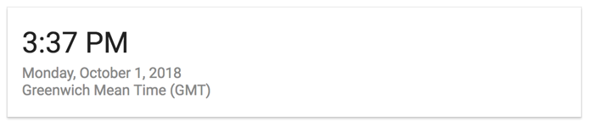

*Figure 28 Getting current GMT Time*

Convert this to Military time (15:37 10/1/18 for the example) and format the Clock Update Message with this time in it. The time is sent in Hexadecimal so15:37 10/01/18 in base 10 is 0F:25 0a/01/12 in hexadecimal, so for the example, the OTA command is 01 5a a5 00 25 0f 00 01

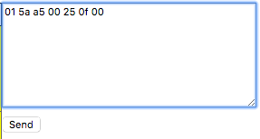

*Figure 29 Entry of GMT Clock Update Message*

At the next time the Modem is turned on, the OTA request is received and an OTA reply is sent. The unit should reply to this message at Midnight GMT that same day.

### Verify Storage Clock Alignment Message

To verify the storage clock alignment message, after the clock alignment test a Clock Alignment message can be verified. The message allows the time to be moved “forward” the number of hours to set the current time in the desired timezone. In the case of Eastern Standard Time, it is 4 hours earlier than GMT. So to set this time zone, the time needs to be adjusted 20 hours forward (24 – 4). To avoid having to wait until midnight to make the test, a time zone adjustment can be picked that places midnight a few hours in the future.

To test the time zone change, build a Storage Clock Alignment message. For a -4 hour adjustment the test the message would be 02 a5 5a 00 00 14

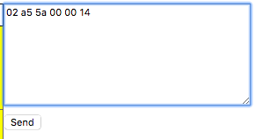

*Figure 30 Entry of Storage Clock Alignment Message*

At the next time the Modem is turned on, the OTA request is received and an OTA reply is sent. The unit should reply to this message at Midnight your time that same day (or whatever time zone you set for your test.

## Testing GPS Requests

The system allows for a GPS test to be requested. Ordinarily the GPS test is done just after activation, but it can also be done manually. Additionally, the default accuracy settings of the GPS measurement can be changed.

### GPS Set Measurement Criteria

To test the setting of GPS accuracy settings, the GPS Set Measurement Criteria OTA message can be sent to the unit. The test will set the number of satellites to 4, the HDOP value to 40 (4 meters) and the minimum measurement time of 1 minute. For these settings the OTA message needed is: 0e 5a a5 04 28 00 3c.

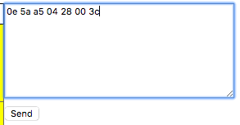

*Figure 31 GPS Set Measurement Criteria Message setting*

### GPS Request New Measurement

Once the settings are changed, a new GPS request can be requested. The OTA message needed is: 0d 5a a5 01

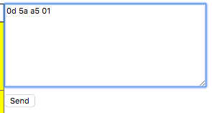

*Figure 32 GPS Request New Measurement Command*

The next time the modem is turned on (midnight), then the OTA request is sent to the Afridev2 unit. After the message is received, then the unit needs to be taken outside for 5 minutes to get a GPS fix. The next time the modem is turned on (midnight again), then the GPS measurement is reported.

### GPS Request Existing GPS data

In another test, the OTA message’s last byte can be changed to a 0 to request the current GPS coordinates. The OTA message needed is: 0d 5a a5 00

The next time the modem is turned on (midnight), then the GPS measurement is reported.

## Testing System Reset Command

### The Afridev2 unit has a few commands that are used to reset the unit’s processor and restart the system.

### Reset Device

When the unit is restarted, all the existing data is cleared out and the unit starts from the beginning. All the previous activities done at installation have to be redone: measure 50 liters of water, Activation, get GPS fix, set clock. To perform this test the OTA message needed is 08 5a a5 aa 55 cc 33.

The next time the modem is turned on (midnight), then the unit is restarted. A Final Acceptance and Monthly Check-in Message should be seen on the BodyTrace server. Note that the unit may need to be re-activated for future tests.

## In-Field Firmware Update

To test the In-Field Firmware Upgrade feature, the Application Image is required.

### Building the Application Image

This is built using the CCS tool to build the Boot and App projects, then running the run.bat app in the Afridev2\AfridevV2ImageBuilder folder.

### Obtain the Firmware Upgrade Message file.

This is a text file that contains a complete Application image wrapped in a Firmware Upgrade Message. For example, with the Outpour version 1.4 release, this file is called: “outpour_MSP430_v1_4_daily_061515_0830_msg.txt”.

### Copy and Paste Contents of Firmware Upgrade Message file to BodyTrace server

Using a Text Editor, open the Firmware Upgrade Message.

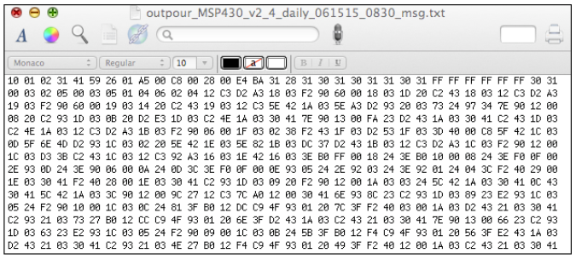

*Figure 33 Contents of Firmware Upgrade Message*

Perform a “Select ALL” and “Copy” operation, copying the complete message to the clipboard or equivalent.

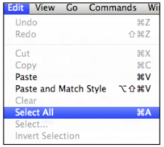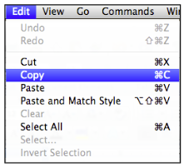

*Figure 34 Selecting and copying all text*

Go to the CQT web site for the Afridev2 unit. In the Message window, perform a paste and send of the Firmware Upgrade Message

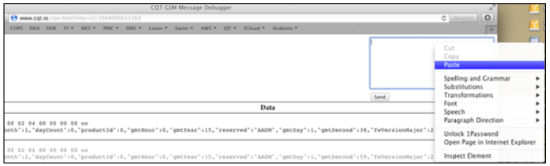

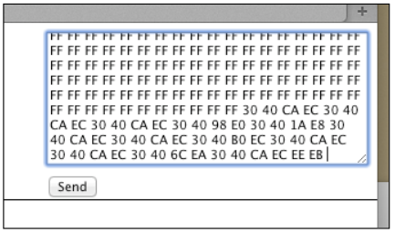

Then next time the Afridev unit performs a Final Assembly, Water Data or Monthly Check-In message, a firmware upgrade will be performed